User guide to run a Python Application on IIS that uses Flask

**Contents**

Document History

Change Record ……………………………………………………………………………………. 3

Reviewers……………………………………………………………………………………………. 3

Introduction…………………………………………………………………………………………………… 3

Prerequisites……………………………………………………………………………………………………. 4

Install Python………………………………………………………………………………………. 4

Install FastCGI and Flask……………………………………………………………………… 5

Setting up Website………………………………………………………………………………………… 5

Open IIS………………………………………………………………………………………………6

Add Site………………………………………………………………………………………………6

Fill Details (Hostname) ……………………………………………………………………….7

Restart and Browse Website……………………………………………………………… 8

Document History

Change Record

|  |  |  |  |
| --- | --- | --- | --- |
| Date | Author | Version | Change Version |
| 08/22/2022 | Shanmukha Srinivas | 1.0 | - |
|  |  |  |  |
|  |  |  |  |

Reviewers

|  |  |
| --- | --- |
| Name | Position |
|  |  |
|  |  |
|  |  |

Introduction

This document describes how to host a python application using Flask framework and IIS.It includes the necessary prerequisites and the steps that need to be followed to add a website.

**Prerequisites**

1. **Install Python.**

* Download web installer.
* Run as Administrator.
* Select custom installation for all users.
* Choose install directory
* Check the box for “Add Pyhton3.7 to PATH”

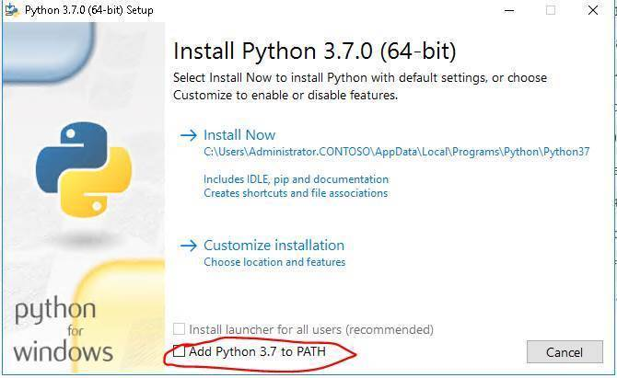

2)Install FastCGI and Flask, and enable them, for this:

* Open command prompt in administrator mode.
* Run the command: **pip install wfastcgi,** this command will install wfastcgi which provides a bridge between IIS and Python using WSGI and FastCGI.

* Run the command: **pip install flask,** this command will install the flask web framework. (I had flask already installed so it is showing requirement already satisfied)

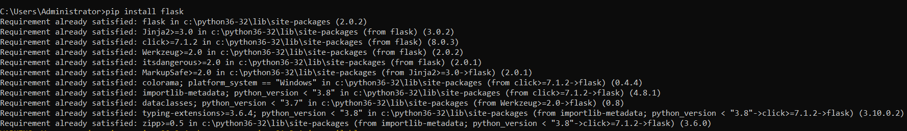

* Run the command: **wfastcgi-enable**, this command will produce the configuration related output.



**Setting up Website**

* Create a repository for your python code and store it in that repository along with the config file.

Make sure you remember the path of the repository; it will be required later. For instance:

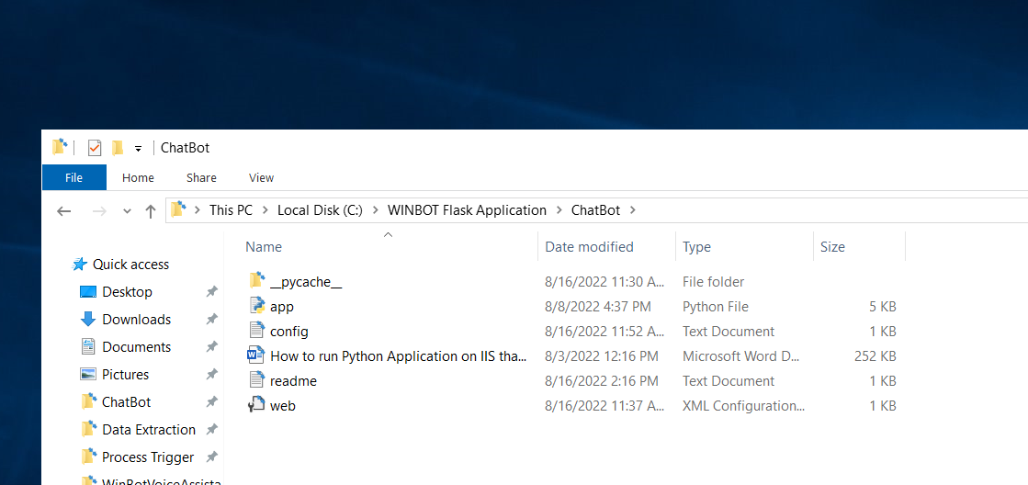

* Open IIS, you can navigate to it by using the search bar, after that click on all dropdowns and you should be looking at something like this: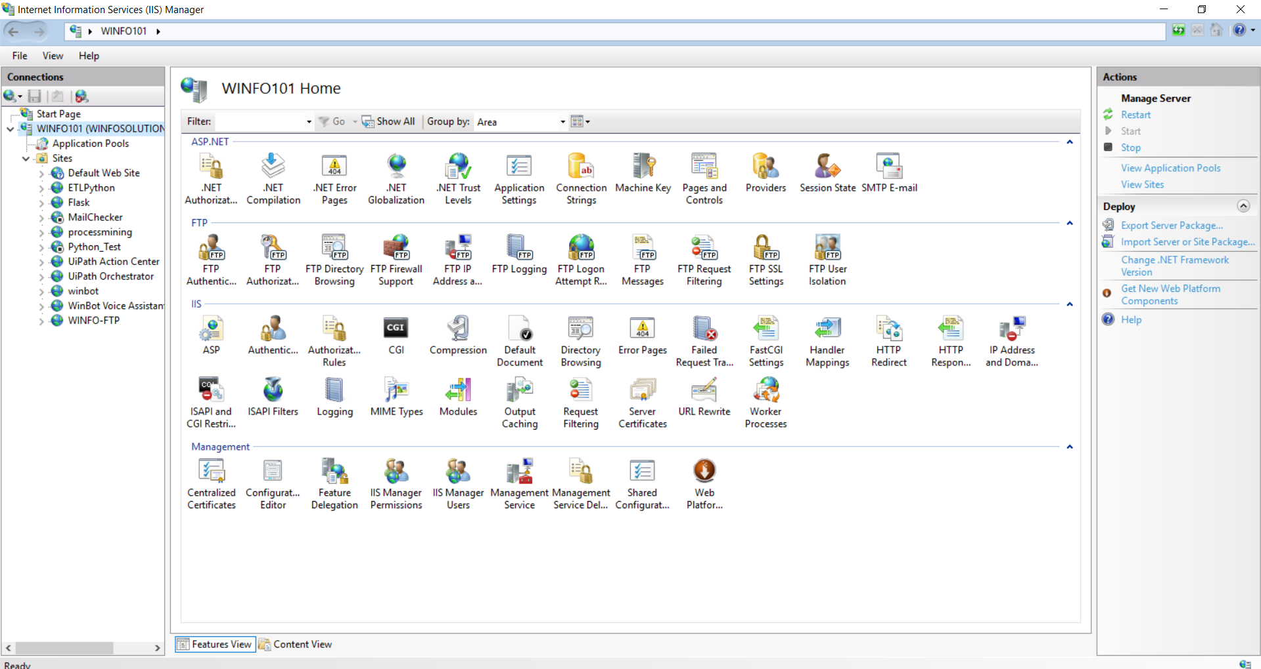



* Then right click on sites, and go to “**Add Website…**”:

1. It will open a pop up and enter the required fields, for this instance I had hosted it in a “https” format, and it looked like this:
2. Graphical user interface, application

   Description automatically generated
3. Note that the same path has been given as in the beginning, assigned the available port number, and for the “Host name”, go to the command prompt and type in “hostname” and just add “.winfosolutions.com” to the hostname. So, in this case it is “**winfo101.winfosolutions.com**”.





1. After that click on “**OK**”, and then click restart to complete the process, to verify you can click on “browse website” and see if you get the desired response.

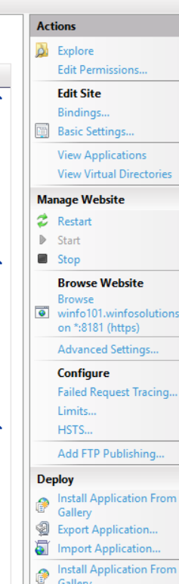

After clicking on “**Browse Website**” you should get something like this:

Please note that, the physical path that we have provided in “Add Website step” contains the following files: web.config, app.py and other .txt files.

* The **webconfig file** contains the web configuration:

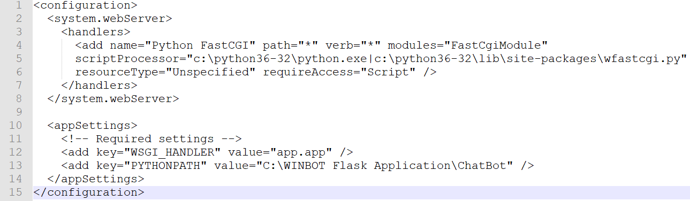



* The **app.py** contains the FLASK application, and has this piece of code:

If you navigate to the root node, which is, “WINFO101”, you will see a lot of configuration features. We are focused on “**FastCGI Settings**” and “**Handler Mappings**”, under the IIS tab.

* Under FastCGI Settings, I have the following:

* Go through the “Handler Mappings” for your site, in my case the site is “ChatBot”, and make sure the “Python FastCGI” is enabled:

